# Progression Framework

## .Net

Was built in 2002.

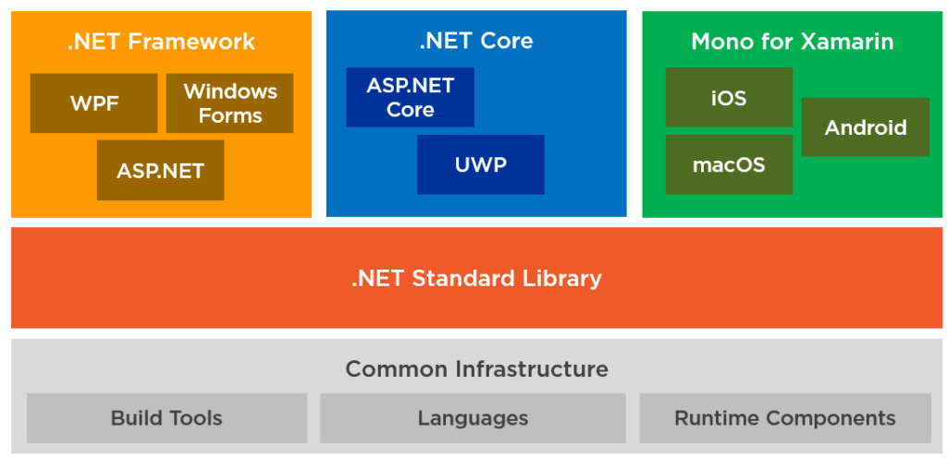

The .Net Ecosystem is made up of:

* Runtime Components:
  + .Net FrameWork : exists since 2002, you can build WPF, Windows Forms, Asp .Net Forms and MVC Apps. Its main purpose is for Windows Desktop Apps.

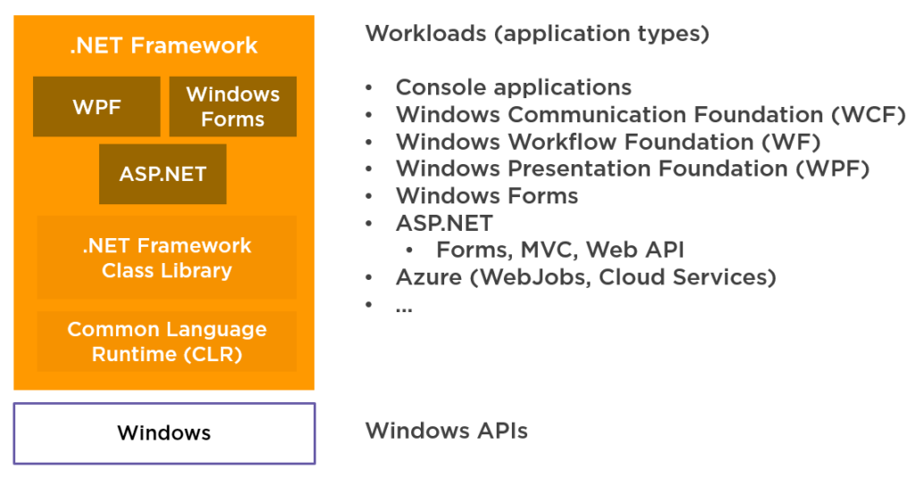

* + .Net Core : Released 2016, you can build Asp .Net core and Universal Windows Platform apps, It runs cross-platform and can be installed side-by-side, meaning that you can have many versions of .NET Core running on the same computer. Its main purpose is Cross Platform Web and Desktop Apps.

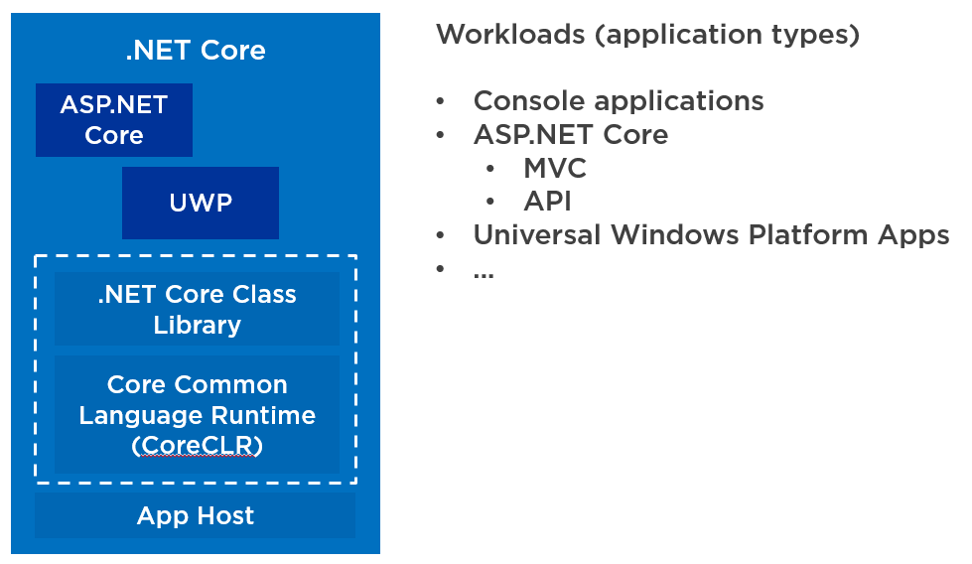

* + Mono Runtime: Used for Xamarin. cross-platform implementation of the .NET Framework and it can run all sorts of applications, like console and Windows Forms applications. Its main purpose is Cross Platform mobile apps.
* Tools and Languages: all the runtimes use tools and languages to compile and run code. This includes languages, like C#, VB.NET and F#. This also includes build tools, like MSBuild and things like the Common Language Runtime (CLR) and the CoreCLR.
* .NET Standard Library: The three runtimes all implement this. It is a set of API specifications which is different per runtime.

## Inheritance and Polymorphism

* + Inheritance is when one class is allowed to inherit features(fields and methods) of another class
  + This is better known as when a child class inherits from a parent class/ or a base class inherits from a super class
  + Polymorphism is when a child class inherits from a parent class but changes the behaviour of that method
  + It can also be described as providing an ability to take more than 1 form.
  + This is a combination of 2 words.. poly means multiple and morphs means forms so basically it means many forms

## Interfaces

* + An interface represents a contract between an object and its user. It is a collection of methods and property declaration’s
  + explicit interfaces is when a single class inherits from multiple interfaces that have the same method signature

## Classes

* Class is a user-defined blue print, basically a class combines the fields and methods into a single unit

## Generics

* Generics allow the user to define classes and methods with a placeholder, this basically allows types and user defined types to be a parameter to methods, classes and delegates.
* Generics allows a constraint to limit the type of arguments being passed

Eg. Where T : type

## Delegates

* A delegate is a reference type variable that holds the reference to a method
* A Delegate is a type that represents a method

## Git

* Another doc added with git commands
* Git is a type of version control that allows you to track changes to your files

## Css3

* Is the latest of the cascading style sheet language. it allows things like shadows, gradients, animations etc

## Html

* Html5 is the latest version of the Hyper text Markup Language.
* It provides more features that previously had to be done in javascript
* Html is used to structure and present the content for the web

## Linked List

* + - Linked list is a linear data structure which consists of a group of nodes in a sequence.
    - Each node contains 2 parts:
      * Data-Each node can store data
      * Address-each node contains an address to the next node if a single linked list but if a doubly linked list then it contains the previous aswell
    - Lined list are easy to implement when inserting and deleting data
    - It has a faster access time.
    - Backtracking is possible

## Stack

* Stack is a special case collection which represent a LIFO concept
* The process of adding to a stack is with a push, to remove is done with a pop

## Queue

* A queue represents a FIFO.
* It is used when you need a first in first out access of items
* To add to a queue is with enqueue, and to remove is with dequeue

## 

## SOLID #Work some more on these especially L and D

### S – single responsibility principle

A class/method should do one thing(job) and do it well. It’s based more on the context of it e.g. You

could have a userManagement controller that would have all the methods in that class (Add, edit,

delete) and you could also have a controller for each user function (AddUserController etc.) they say

methods should have 2-3 lines but that’s not really true, it more depends on the context of the

code.

### O – open closed principle

Open for extension and closed for modification.

Simply means a class should be easily extendable without modifying the class itself.

Be able to change the behaviour by only adding or removing code.

### L – liskov substitution principle

This allows you to replace any instance of a parent class with an instance of 1 of its child classes without negative side effects.

This requires the subclass to behave the same way as the parent class.

Eg of this was the duck example.. the parent class is a duck and the method is quack.

When a diff type of duck inherits from the duck class it still quacks with a quaaack.

But if a rubber duck inherits from a duck .. it cannot quack so it returns a not implemented exception

which then breaks the app.

<https://www.youtube.com/watch?v=ObHQHszbIcE&list=RDCMUCbF-4yQQAWw-UnuCd2Azfzg&index=1>

### I – interface segregation

This basically states that no class should be forced to depend on methods that it does not use.

You should instead create a new interface and let your class implement multiple interfaces.

### D – dependency inversion

This is a way to decouple modules. We use dependency injection to use other classes methods in our app.

High level modules should not depend on low level modules. Both should depend on abstractions.

Advantages: Increases recuse, encourages small classes with limited responsibilities. Testability, allows to mock other classes and allows to test in isolation.

## Pair Programming

* Pair programming is when 2 developers work together on one work station.
* One is the driver, he or she has the keyboard and does the typing
* The other is the observer or navigator who reviews the code as its being typed.
* The two should switch roles often.

## Periodic retrospectives

* This is a technique that is done to find out if the team can improve in any ways
* Usually its a like, dislike, more off and keep doing
* Its the dislikes and more off that’s the most important feedback
* Can be done weekly, depending on team and size of the team

## -Kaizen

* This is a Japanese philosophy
* Kai meaning change and zen meaning good
* This means to continuously improving
* A good example of this would be to do katas often which will improve dev skills

## Continuous integration

* CI is a practice where developers integrate code into a shared repository frequently. at least 1 commit a day is best.
* Each integration can then be verified by an automated build and automated tests.
* Example of this is azure devops

## Office 365

* I would say I am an advanced beginner in Office 365 as I attended a course when I was at campus.

## Sonar

* I used this tool once in Fortel, it basically gives an overview of the project and what can be improved.
* It has a rating of high, medium and small issues. Some of the issues have examples of how it can be fixed.
* This is a good tool if you are looking to improve your application and also helps with maintainability of the project
* Static code analysis tool

## Windows

* It is an operating system produced by Microsoft
* -#not sure how to explain windows